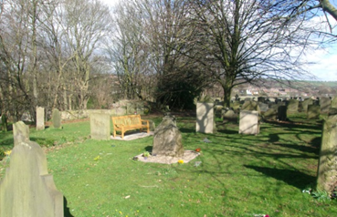
Whiston Parish Church
Rectory Drive
Whiston
Rotherham
S60 4JG
Tel: - 01709 364430
Email: - whistonparishchurch@gmail.com
Web:-www.whiston-parish-church.org.uk
Application for inscription on the Memorial Stone
in the Cremated Remains area.
PRINT Name Required:-

--------------------------------------------------------------------------------------------------
Year of Death: -
Year of Birth: -
The PCC requests £130 per inscription on the new memorial stones.
Gift Aid declaration.
I wish to gift aid my £130 to Whiston Parish Church. I note that I must pay an amount of UK Income Tax or Capital Gains Tax at least equal to the amount of tax reclaimable on my £130 to you in the current tax year.
Date: Signature:
Please make Cheques payable to Whiston Parish Church.
Applicant contact details
Contact Name:-
Contact details & Contact number:-

---------------------------------------------------------------------------------------------
Information & money received with thanks for:-
For Name:-

Received by: - Date:-

